Tier 1 Policy/Practice Document: Basic and Academic Behaviours- RAG Analysis
Fidelity Key: Embedded (85% use), embedding, to be embedded
Basics | Strategy | Notes / School-wide Script | Method of Monitoring | Fidelity  (What percentage of staff and children know the routine?)
 | Basic Behaviours
Y | Getting the attention of the whole class for 2-5 minutes. | Year x, stop and look at me. Thanks for looking at me; you’re looking at me. I’m only going to talk for x minutes.  Anti-script examples:  Shouting.  Why aren’t you looking at me?  I’m waiting!  Everyone’s waiting for ...  You won’t know what to do if you don’t listen.
Y | Managing noise levels in classroom | Silent Voice: a voice in your head only. (Not communicating verbally or nonverbally.)  Partner Voice: a voice only your partner can hear.  Table Voice: a voice only your table can hear.  Classroom Voice: a voice that everyone in the class can hear.  E.g. Thanks for using a partner voice.  Thanks for using a table voice.  We’re going to use a silent voice for this activity.  Anti-script examples:  It’s getting really noisy.  QUIET!  I can’t hear myself think.
N | Arrangement of classroom tables | 1  3  4  5  6  2  Front of class  Can number 1s go and get the maths books. Can number 2s collect the Literacy books, the right way up and the right way round. etc
Y | Numbered heads (1-6) for discussion and feedback. | Eg Number 1s, can you choose the best three ideas your table had come up with? You’ve got 60 seconds to make your choice and share with the group. I’ll then be coming to another number on the table to feedback the 3 ideas.
Y | Walking in school | Thanks for walking (in school).  We say this every time we see a child walking in school.  Anti-script examples:  Stop running.  Why aren’t you walking?  Well done.  Can I see your walking in school?  Show me nice walking.
Y | Giving warnings with a reminder of the rule and use of the language of fairness. | Pam, warning. The instruction is to use a silent voice.  Or Pam, that’s your second warning. The instruction is use a silent voice. Can you sit on your own for 5 minutes. Thank you.  I will be fair on you.  Anti-script examples:  Warning; you were talking.  Warning; do you know why you got that.
Y | Use of “Thanks for…” as a way to increase positive to negative ratio (Ideal minimum of 10:1 positive to negative.) Also used as a way to cue warnings. | Eg Thanks for using a partner voice.  Thanks for putting eyes on me.  Anti-script examples:  Thanks. (Thanks for… is 100 times more effective.)  Well done.  Good girl; good boy.
N | 3:1 CWR to Warnings ratio | Staff aim to give 2-3 times as many CWR as warnings, focusing on giving most CWR to those students most likely to get warnings/ those getting most warnings.
 | Response when children tell-tales | The Investigation Test:  Has anyone been hurt, either physically or verbally?  Has anything been damaged?  Has anything been stolen?  If yes, refer to Learning Mentors.  If not, remind everyone of the rules. Eg If someone has reported bad language, gather all those who may have been involved and remind them all of the instructions. Then monitor the group and deliver consequences as necessary.  Anti-script examples:  What’s been going on over here?
 | Classroom Management
 | s. | Beginning of each lesson or session will begin with a Do Now. These tasks should require no input from the teacher. Children expected to settle down to an activity straight away when they enter the classroom.  Most effective when routine is consistent.
 | Board = Paper | Background on flipcharts should mimic the paper in the children’s books. E.g. Lined paper for English lessons and squares for Maths lessons.
 | Children speak in standard English | Children who use the incorrect subject-verb agreement e.g. We was playing. I done it yesterday should be corrected and ask to repeat the correct sentence.  E.g.  Child: I done my homework last night.  Teacher: You mean, I did my homework last night.  Child: I did my homework last night.  Anti-script examples:  Say it properly.  That’s not how you say it.
 | Presentation in Books | Maths: Children write in pencil  All other subjects: KS1 write in pencil, KS2 write in black pen.  Maths:  - Short date- aligned left  - Miss a line  - LI: (No capital letter after the colon)  - Target card number  English:  - Long date Monday 14th May 2018- aligned left  - Miss a line  - LI: (No capital letter after the colon)  *All dates and LIs to be underlined with a pencil and a ruler.  Examples stuck in front of Maths and English books showing school expectations, alongside calendar so children never need to ask for the date.
 | Response when students say they are stuck. | Maths: Mild, medium hot with answers: “I’ll help when you’ve done five questions.”
 | Response when students say they have finished their work.
 | Response when student asks to go to the toilet.
 | Response when student asks to go for a drink.
 | Response when questions or comments are off-task
 | Regular checks of pupils’ progress within lesson using Random Pupil Chooser. Cut and paste class list, save and share the link. | I’ll be asking chosen students to come and show me their work and I’ll be putting in under the visualiser.  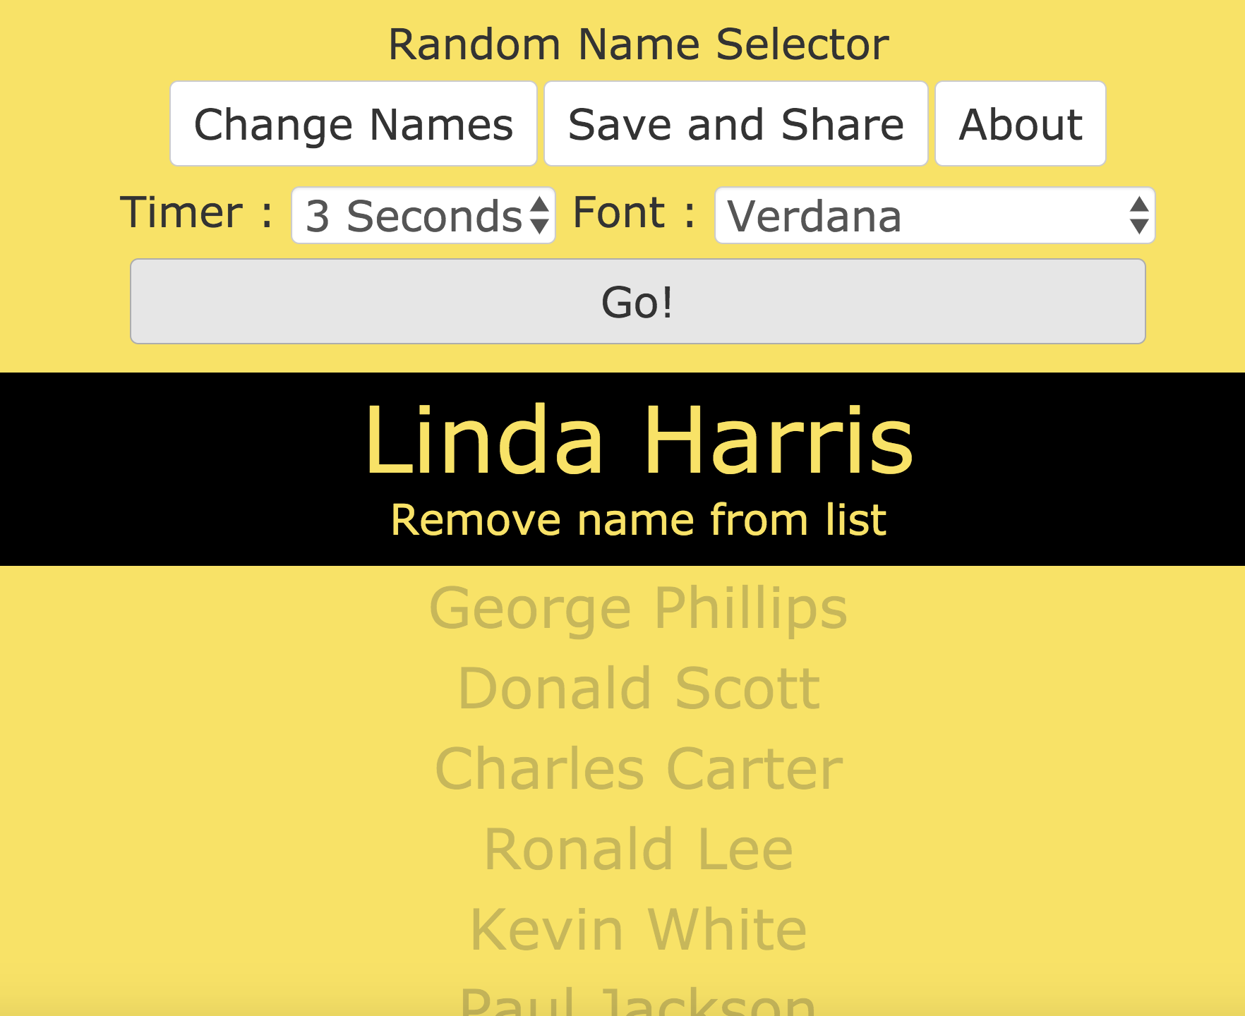
Talk tasks:
Peer-work forms at least part of lesson. Children know their partners eg 1-2, 3-4, 5-6. Specific questions for 30 secs?
When appropriate, planning includes checklists or check-points, for students/peers to evaluate/improve.
 | Seating plans in place, which include factors on resilience and Tier. See Seating plan example. | Seating plans should be carefully considered and put in behaviour folder for reference.
 | Children answer the register using the teacher’s name. | E.g. Good morning Charlie  Good Morning Mr Daniels. Red dinner please.  Good afternoon Charlie  Good afternoon Mr Daniels.  Anti-script examples:  Charlie?  Here!  Yes.
 | Weekly behaviour chart stuck on the front of a behaviour file. | The behaviour folder must follow the class around school and warnings recorded when they occur.  The behaviour folder also includes important information for teacher such as line order and seating plans.
 | Tier 2 and 3 Interventions
 | Use of FBAs | Choose 3-5 students to do FBA with and for.  Share doc with everyone. Choose the strategies to try for 4-6 weeks.  Choose from the selection at www.pbisworld.com

